Analysis on the WORST-solution provided by AI

I believe there are several areas on this answer for improvement in the World Cup Angling Championship system design generated by ChatGPT, even compared to other two solutions.
- Competition Section and Entrant Entity:
The competition section within the ‘Entrant’ entity must be created separately, as "Today's Qualifying Anglers" for the finals need to be managed individually for each competition section. This allows for accurate tracking and execution of the qualifying process across different sections of the competition.
- Entity Improvements for Competition Day and Fish Catch:
The entities representing Competition Day and Fish Catch can be further optimized as outlined below:
- Competition Entity (formerly Competition Day):
  - Competition_ID (Primary Key)
  - Competition Date
  - Boat Number
  - Boat Person_ID (Foreign Key)
  - Entrant Name (Foreign Key)
  - Fish Catch_ID (Foreign Key)
- Fish Catch Entity:
  - Fish Catch_ID (Primary Key)
  - Number of Fish Caught
  - Total Weight
  - Heaviest Fish Weight
  - Boat Person's Signature
This restructuring improves clarity and ensures proper identification and association between entities during the competition – Improved diagram attached below.
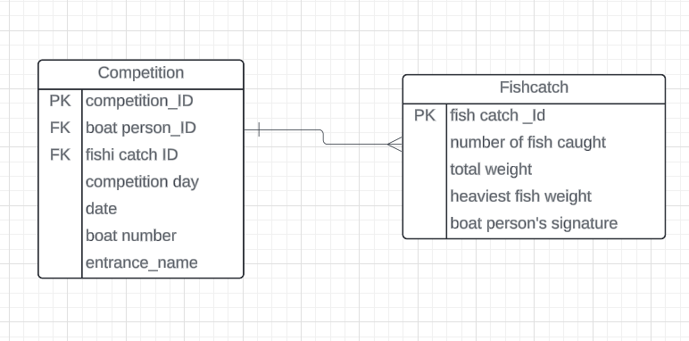

This part was missed on the solution provided by Chat GPT- a lottery must be held to determine who proceeds to the final. The system generates labels with anonymized IDs for each person in the draw, and the labels are placed in a transparent drum for the draw. Lottery qualifiers have their entry status changed to Lottery, while those who qualify by right have their status changed to Qualifier.
To manage this effectively, it is recommended to introduce a new entity, Entry Status, which will track the status changes of each entrant. This additional entity will help prevent anomalies in the ‘Entrant’ entity when there are updates to an entrant's qualification status.
Availability Status and Boat Person Entity:
Similarly, the Availability Status for the “Boat Person” entity, which includes the statuses Available, Unavailable, Reserve, Boating, and Fishing (as an Enum), should be placed in its own separate entity. This new entity, Availability_Status, would then be linked to the Boat Person entity, creating a one-to-many relationship, where one status can be associated with many boat persons. This structure allows for better flexibility and scalability in managing the availability of boat persons during the competition.

Necessity of the Past Event Table:
It appears that the Past Event table may not be necessary within the current system design. Linking the entrant ID as a foreign key would only display current year entrants; however, entrants from previous years would not be relevant to the current year's competition. Since past entrants do not have a direct relationship with the present competition, their inclusion could introduce confusion or data redundancy.
Boat Person Entity Attributes:
The attributes within the Boat Person entity seem well-organized, reflecting the system’s requirements. A boat person can either be an entrant or a volunteer, with the EntrantID set as a foreign key (nullable) that references the Entrant entity (EntrantID). This design ensures that a boat person’s role is clearly defined and allows the system to distinguish between volunteers and competitors efficiently.

